**Case Study Assignment: Exploring Field Test Mode on Smartphones**

**IMEI Number:**

The International Mobile Equipment Identity (IMEI) is a unique identifier for each mobile device. It plays a crucial role in identifying the device on cellular networks, enabling it to connect securely. IMEI numbers are essential for tracking lost or stolen devices and for network security.

**MAC Address:**

The Media Access Control (MAC) address is a unique identifier assigned to the device’s Wi-Fi module. It is used within local area networks (LANs) to help identify devices.

**IP Address:**

The IP address (Internet Protocol address) is assigned to the device by the network to enable internet connectivity. It allows the device to send and receive data over the network. IP addresses can be dynamic (changing each time the device connects) or static (permanently assigned).

**Network Type:**

This parameter shows the mobile network technology currently in use (e.g., 4G LTE, 5G). Each network type offers different speeds and capabilities, with 5G providing faster data rates and lower latency compared to previous generations.

**Signal Strength (dBm):**

Signal strength measures the power level of the network connection, typically in dBm (decibels per milliwatt). The closer the value is to zero, the stronger the signal. For example, -50 dBm is a strong signal, while -120 dBm is weak.

**Mobile Location Information (LAC and CID):**

The Location Area Code (LAC) and Cell ID (CID) help identify the device's location within the network’s cellular structure. This information is used to determine the coverage area and the specific cell tower the device is connected to. It can assist in troubleshooting network issues and optimizing coverage.

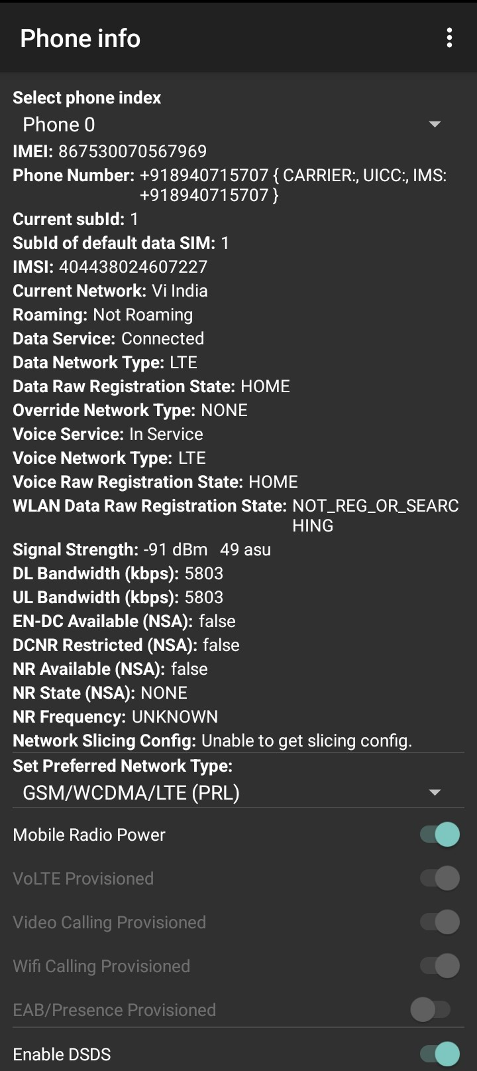 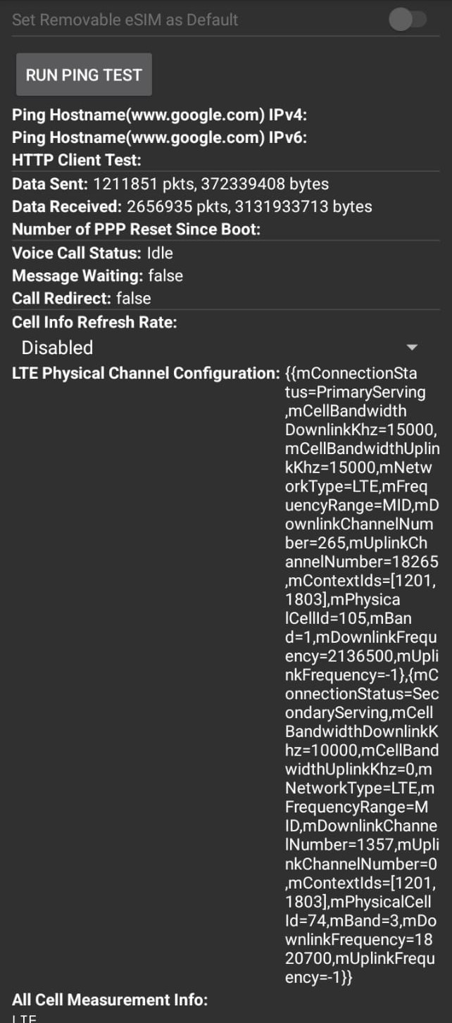

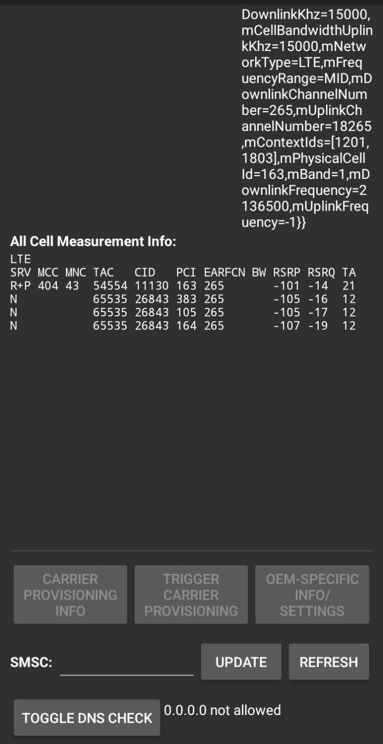

**Conclusion:**

This case study provided valuable insight into the network parameters accessible via Field Test Mode on an Android device. Understanding these technical details is crucial for diagnosing network issues, enhancing device security, and optimizing connectivity. This experience demonstrated how easily we can access and interpret diagnostic information, which is valuable in both personal and professional network troubleshooting.